Symetric cryptography
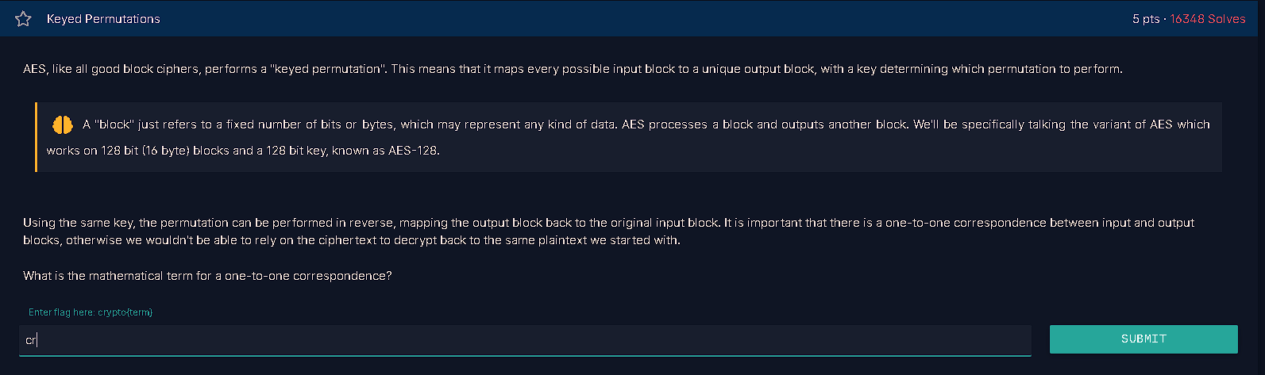
The answer is a bijection and a bijection is a mathematical function that creates a one-to-one correspondence between two sets.

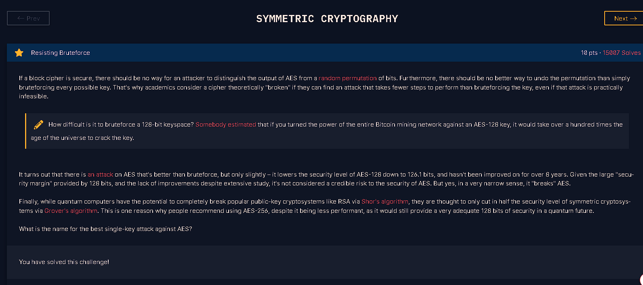
The best known single-key attack against AES is called the biclique attack. It slightly reduces the effective security of AES-128 from 128 bits to about 126.1 bits

